WESTERN STATES WATER COUNCIL

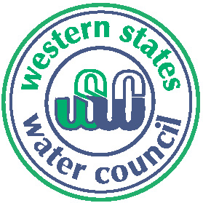 175th Council Meeting
Helena, Montana
July 16-18, 2014

Holiday Inn Conference Center Downtown ADVANCE REGISTRATION FORM
22 North Last Chance Gulch
Helena, Montana 59601 Please return by June 30, 2014
1-406-443-2200

Wednesday, July 16 ► Field Trip

A field trip has been arranged for Council members and their guests. Please meet in the hotel lobby at 11:50 a.m. for departure. The bus will depart from the hotel at Noon.

On July 19, 1805 members of the Lewis & Clark expedition moved upstream through this magnificent stretch of the Missouri River known as the Gates of the Mountains. Join us as we embark on this scenic boat trip where towering walls of limestone stand guard over the river.

Lunch will be served prior to departing on the boat trip. Please wear comfortable walking shoes, bring a hat, lightweight jacket if needed, sunglasses, sunscreen and an umbrella in case of rain, or as sunshade.

It is anticipated we will return to the Holiday Inn around 5:00 p.m.

Cost: $ 50.00 per person

1 - $50 2 - $100
Number attending Field Trip (at $50 each) # Amount Enclosed $ _________

Attendee Name(s)

___________________________________________________________________________________________________

Title

Company or Agency

Address

City/State/Zip

Telephone Email __________________________________________________

PAYMENT OPTIONS: Payment may be made online via our PayPal link, or via check, credit card, purchase order, or ACH electronic transfer. Please notify us if your agency pays via electronic transfer. Our ACH routing number is 124002971 and our Federal Tax ID is 93-0551574.

Email to: credding@wswc.utah.gov OR Fax to: (801) 685-2559 OR
Mail to: Western States Water Council, 5296 Commerce Drive, Suite 202, Murray, UT 84107-5340

