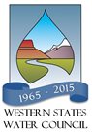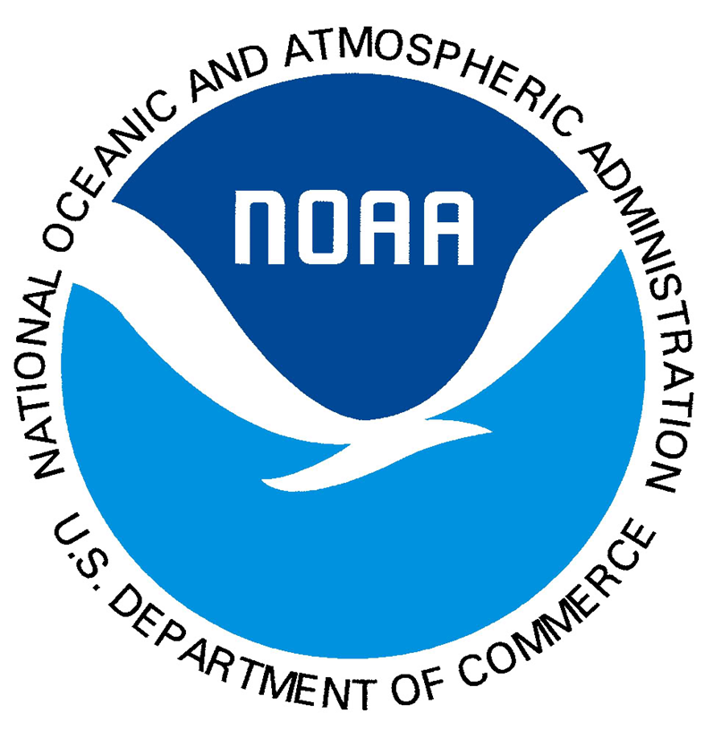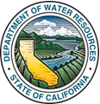

Advancing Seasonal Precipitation Forecasting Workshop

Sponsored by:
Western States Water Council & California Department of Water Resources & National Oceanic & Atmospheric Administration

December 15, 2015
Caesars Palace - Las Vegas, Nevada

The Western States Water Council, California Department of Water Resources and National Oceanic and Atmospheric Administration have organized a workshop on December 15 to be held at Caesars Palace in Las Vegas, Nevada. This workshop will begin at 8:30 a.m. and adjourn around 3:00 p.m., and is being held in the Pisa Room.
The purpose of the workshop is to help water resources managers better understand current forecasting capabilities and the state of the science, as well as how to develop examples of regionally-specific opportunities for improving forecasts and associated information on economic benefits that could be used for supporting a focused federal research effort.
To register, please fill out the following information and return this form to Julie Groat at jgroat@wswc.utah.gov, or via fax (801) 685-2559.

No Registration Fee

NAME:

TITLE:

AFFILIATION:

ADDRESS:

CITY: STATE: ZIP:

PHONE:

EMAIL:

If you do not receive a registration confirmation, please contact Julie Groat at (801) 685-2555, or email: jgroat@wswc.utah.gov.

