Workshop on

Improving Long-Range Weather Forecasts
and
Sub-Seasonal to Seasonal Precipitation Forecasting
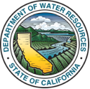
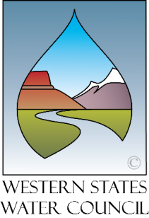
Sponsored by:

Western States Water Council
and
California Department of Water Resources

May 17-19, 2017
San Diego, California
Doubletree San Diego Downtown

The purpose of the workshop is to support water management decision making through improved precipitation forecasting. The agenda includes lessons learned from recent years’ seasonal outlooks, updates on scientific research on sources of skill and predictability, and programmatic efforts to improve forecasting. Increasing forecast skill will require a sustained investment over time, prioritizing the federal resources necessary to make progress, and a specific focus on the West. Strategies for improving precipitation forecasting will be discussed.

Please complete this form to attend the workshop, which will begin Wednesday at 1:00 pm and conclude Friday, around 12 noon. For room reservations, contact the hotel directly at 1-619-239-6800 and ask for the Western States Water Council group room block.

No Registration Fee

Name

Title

Company or Agency

Address

City/State/Zip

Telephone Email __________________________________________

Please return this completed form to Julie Groat at jgroat@wswc.utah.gov or via fax to the WSWC offices at 801-685-2559.

