## **Western States Water Council**

## and

## **Interstate Council on Water Policy**

**WASHINGTON D.C. ROUNDTABLE**

**and**

**WSWC 186th COUNCIL MEETINGS**

### March 14-15, 2018

### Crystal Gateway Marriott Arlington, Virginia

### REGISTRATION

The Western States Water Council and Interstate Council on Water Policy are cosponsoring a Water Planner’s Conference and Roundtable in Arlington, Virginia on March 14-15, 2018. The 186th Council meetings, Joint Water Planner’s Conference and Joint Roundtable will be held at the [Crystal Gateway Marriott](http://www.marriott.com/hotels/travel/wasgw-crystal-gateway-marriott/?scid=bb1a189a-fec3-4d19-a255-54ba596febe2) located at 1700 Jefferson-Davis Highway. A number of topics will be addressed at the Roundtable by federal agency representatives, including a Congressional panel with key committee staff.

We expect another excellent roundtable. The schedule provides opportunities for informal interchange and discussion.

***Please check one below: Amount Paying: $__________***

**__ ICWP Member Registration Fee - $325** (by Feb 13); **$375** (after Feb 13).

**__ WSWC Member Registration Fee - $325** (by Feb 13); **$375** (after Feb 13).

**__ Non-Member Registration Fee** - **$375** (by Feb. 13) and **$425** thereafter.  
**__ Colleague Discount** - A discount of $50 each for 2 or more registrants from the same agency.

**__ One-Day Registration** - $175 for Wednesday, 3/14; $200 for Thursday, 3/15

Name __________________________________________________________

Title ___________________________________________________________

Agency or Company ______________________________________________

Address ________________________________________________________

City, State, Zip __________________________________________________

Email __________________________________________________________

Telephone_____________________________

Email to: credding@wswc.utah.gov OR Fax to: (801) 685-2559

***PAYMENT OPTIONS****: Payment may be made online via credit card on our* [*PayPal link*](http://www.westernstateswater.org/wswc-spring-2018-council-meetings-and-washington-dc-roundtable/)*, or via check, purchase order, or ACH electronic transfer. Please notify us if your agency pays via electronic transfer. Our ACH routing number is 124002971 and our Federal Tax ID number is 93-0551574.*

***Sponsors are welcome and encouraged to contact Tony Willardson, WSWC Executive Director (twillardson@wswc.utah.gov).***

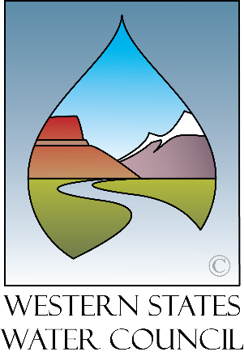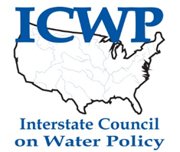

Western States Water Council

682 East Vine Street, Suite 7

Murray, UT 84107

Phone: 801-685-2555

Phone (801) 685-2555

www.westernstateswater.org