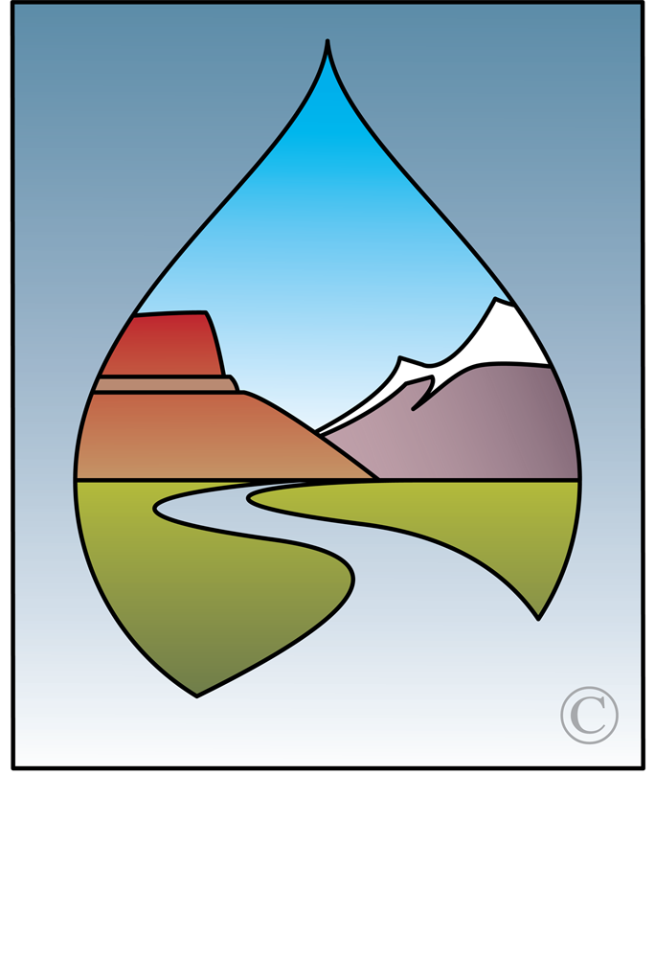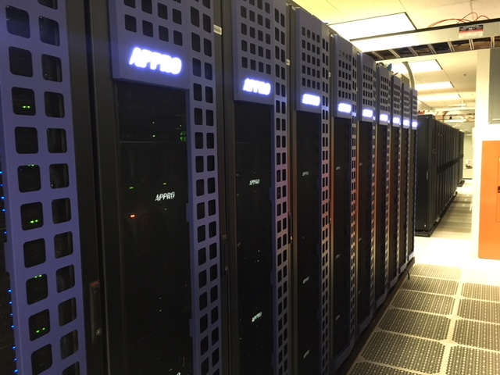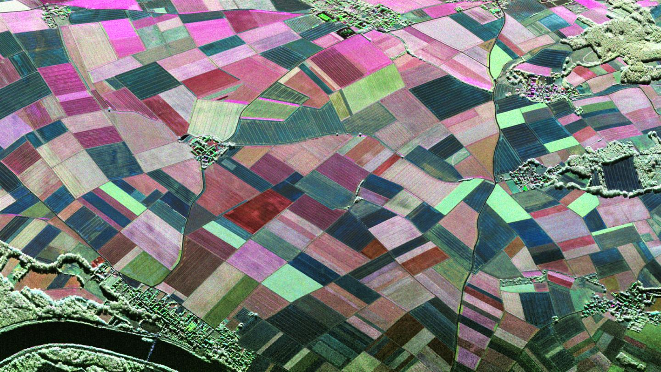

The ability to acquire, process, maintain, and publish data and metadata related to water resource management is a critical and foundational activity that supports administration and planning by western water resource agencies. Projects, models, and the number of observations related to hydrology and watershed dynamics are rapidly increasing in complexity, spatial, and temporal scale. They are also increasing in computational requirement due to the exponential proliferation of sensor-based data, the availability of free and low-cost remote-sensing imagery, and the variety of parameters that can now be brought into the modeling process.

High Performance Computing (HPC) and cloud computing platform technologies offer solutions to the challenge of maintaining distributed or massive datasets, but there are also barriers to their adoption by state water agencies. Cloud computing platform selection, staff training needs, mismatched funding regimes, and unclear security requirements continue to be an impediment to widespread adoption. The acceptance of standardized security solutions for large federal agencies and other entities has been a pivotal development for smaller government agencies experimenting with the idea of storing data or maintaining their applications in the cloud. While a handful of states have fully embraced the notion of using cloud vendors and platforms, there is much less clarity within others.

This report, sponsored by the Western States Water Council and NASA’s Applied Sciences Program (ASP) and the Western Water Applications Office (WWAO), explores the advantages, challenges, current usage, and current policies regarding the use of cloud computing and related technologies among state water resource agencies in the West.

Executive Summary

Western State water resource agency USE OF CLOUD Computing Technology & platforms

WSWC-NASA approach

There is a growing need to understand how states and local water resource agencies can effectively use cloud computing resources to sustain the new tools and capabilities offered by WSWC and NASA ASP/WWAO research teams. Both organizations have a strong interest in 1) understanding existing policies and guidelines on use of cloud computing resources; 2) identifying barriers to development or implementation of these policies; and 3) identifying best practices and case studies that could inform and accelerate adoption of cloud computing resources to enhance and sustain newly developed services and tools. Via a survey, a targeted workshop, and this summary report, WSWC and NASA’s ASP/WWAO have reviewed the policies and organizational constraints within western state water agencies that may tilt the scale for or against cloud solutions. Several case studies of agencies’ experiences with the cloud illustrate its benefits and reveal its challenges and remaining barriers.

Water Information Management System (WIMS)

To fully understand states’ capabilities and limitations, additional questions were investigated regarding cloud usage, data formats, hosting, etc. These questions helped the NASA ASP/WWAO team achieve a greater understanding of how to transition large remote-sensing projects and tools into water agency operations and decision-making. Breakout sessions amongst the workshop participants were key to understanding how management practices vary within the states, and how partners on NASA projects require ongoing communication and collaboration. Early consultation, ease of data availability, use of standardized formats, and inter-office engagement and training were emphasized.

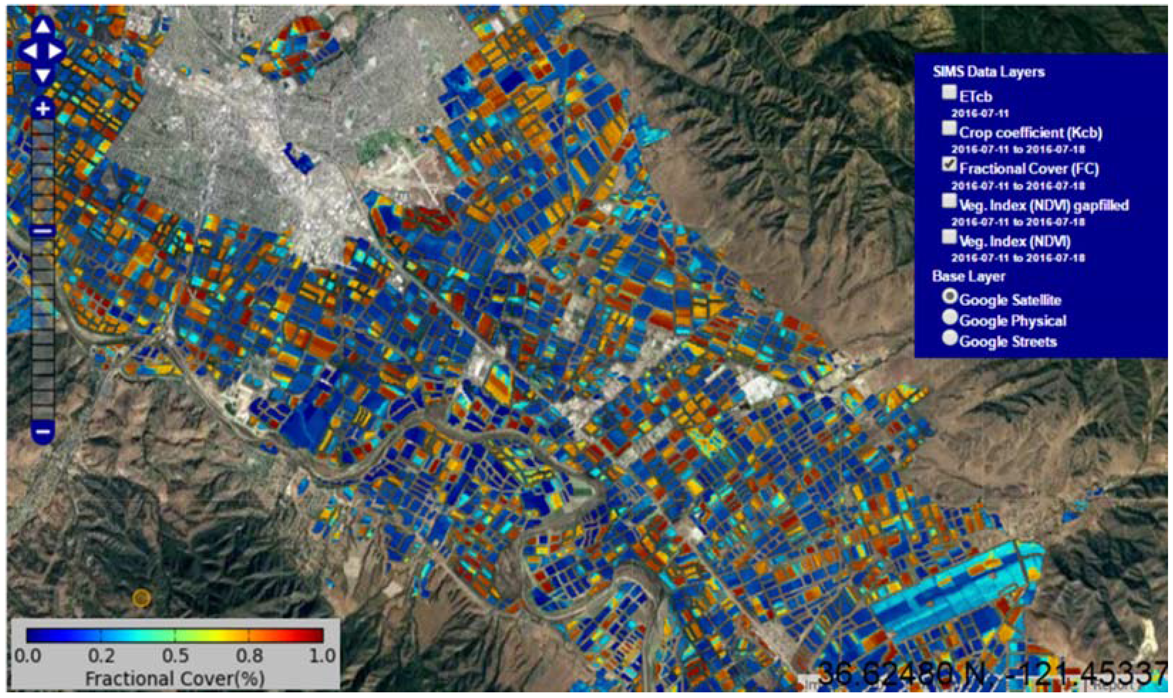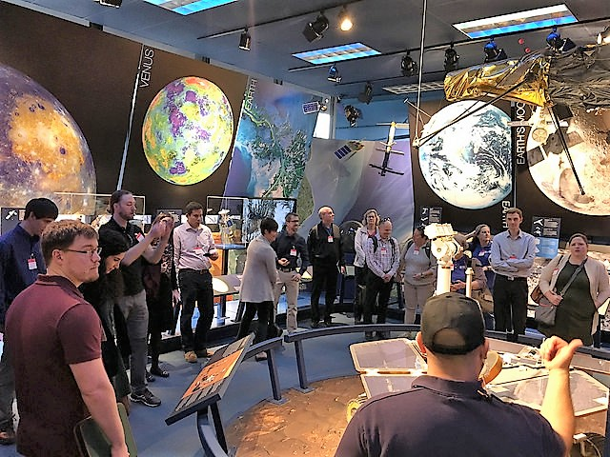

State water resources agencies in the West face myriad challenges when working to complete mission-critical data programs. Many are taking their first tentative steps to include cloud computing and services in their suite of tools and strategies for water management. Some experiences with the cloud have been positive, while others have revealed challenges to greater implementation. WSWC and the NASA’s ASP/WWAO team will continue to investigate what platforms and financial arrangements work well for their members and project co-sponsors. They will continue to strive for better relationships with project co-sponsors in support of their long-term data management needs. This may include governance bodies and partnerships that share in the benefits and costs when hosting and processing large datasets in a cloud environment.

SURVEY RESULTS

WSWC delivered a survey to the data program and IT managers of their membership to determine the extent of their reliance on centralized IT service groups, whether they currently use cloud services, why or why not, and what their experience has been with the cloud from budgetary, performance, and maintenance perspectives. All WSWC member states responded and provided a wealth of information regarding their data programs.

Wswc and nasa projects: Future of cloud computing

Photos and Graphics: S. Larsen, DLR, CC-BY 3, F. Melton