Water Information and Data Subcommittee
Combined Workgroup 3 and Workgroup 4 call

Minutes – May 11, 2012

Attendees: Steve Malers (Riverside), Sara Larsen (WSWC), Dharhas Pothina (TX), Levi Brekke (Reclamation), Dave Cole (UT), Dwane Young (WSWC-WestFAST)

Next Call: Week of June 11th or Week of June 18th (look for a Doodle Poll)

Administrative: The minutes were approved. Dwane mentioned that Sara was drafting a Glossary as requested in the prior call. Once this is drafted, the WSWC will share this with the group for them to review and to add to.
Data Schema Discussion: Dwane walked the group through the database tables that match the XML schema that was discussed during the prior call. The WSWC has developed the database in Postgresql. At the time of the call, the WSWC had developed the table structure for all of the summary data and loaded the database with example data that the WSWC had received from the Sandia National Lab. The WSWC was able to load example data into all of the summary database tables, with the exception of the Administrative Restrictions and the Allocations. The WSWC is still looking to find example data for these sections of the database.

Dwane discussed each table-

Organization: The Organization table is the main parent table. It contains the owner and contact information for the data. Every unique group (or data owner) would have their own unique organization ID, with corresponding contact information.
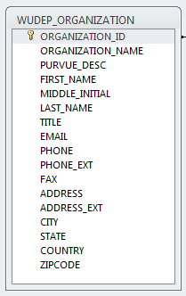
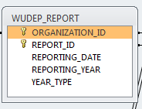
Report: Report is child of Organization. It contains a unique identifier, a date that the report was generated on, and a reporting year. Dwane reminded the group of the discussion from the prior call regarding Calendar Year vs. Reporting Year. In the database, the WSWC has added a column to indicate the type of year being reported. Dwane said that he wasn’t sure if this was the best approach. What he proposed was that the workgroup put together a series of options that could be elevated to the Water Information and Data Subcommittee of the WSWC. Our current thinking is that this year would always represent a Calendar Year. The three options that would be provided to the Subcommittee are:

- Year always represent Calendar Year
- The type of year could be variable, with the data provider specifying the type of year that’s being reported
- The year data element would be moved to the summary data level to be reported for each summary.
Steve Malers stated that Calendar Year may be fairly easy for the states to derive, but it would depend on how their data are currently tracked. If they currently store their data as monthly summaries, then organizing that data by Calendar Year wouldn’t be a problem. Even if they didn’t organize by month, they should be able to convert from Water Year to Calendar Year by making some basic assumptions about water over the winter months.
Action Item: Write up three options for Reporting Year for consideration by the Water Information and Data Subcommittee
Reporting Unit: Reporting Unit is a child of Report. The reporting unit defines the location by which the summary data are organized by. The example data from Sandia had three different types of reporting units: 1) 8-digit HUCS, 2) Counties, and 3) State specific basins. The WSWC was able to load all of these different types of reporting units. For the 8-digit HUCS, the HUC field in the Reporting Unit table had to be populated. For the Counties, the County FIPS column needed to be populated. For the state specific basins, neither of these needed to be populated, but the data provided would need to reference a geographic coverage that provided the extent of the reporting unit.
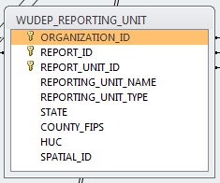
Summary Use: This table would store the use summaries for each reporting unit. Each summary record would need a unique sequence number identifier. Although this is needed for the database tables, it is not required in the XML Schema. Beneficial Use ID ties to the specific beneficial uses as described by the state. Method refers to the method used to derive the use estimate.
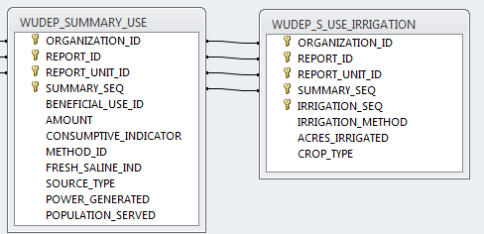
Summary Availability: This table would store the availability summaries for each reporting unit. The timeframe data element in the database table still needs to be changed to start date and end date (as per our discussion on the last call). Availability summaries can be reported as either amounts in acre feet (with the appropriate method used for deriving the value) or as a relative metric.
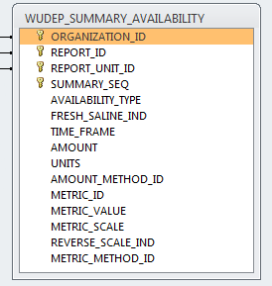
Summary Allocation: The WSWC didn’t have example data for allocation summaries. The table structure for allocations is very similar to use, with the exception being that you don’t need a method to correspond with a value.
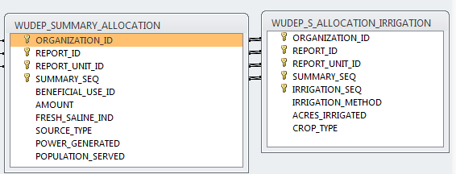
Summary Supply: This table provides a summary of the water supply by water supply type (i.e. storage, snowpack, flow, etc.) within the reporting unit. A supply summary would have a ‘supply type’, an ‘amount’, and a method used to derive the amount. Sandia had provided storage estimates for the 8-digit HUCs in CO. These were loaded into the database.
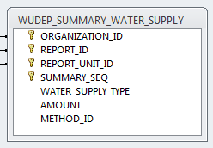
Summary Regulatory: This table provides the summary information for restricted basins (i.e. groundwater management areas, etc.). The WSWC did not have any example data for these basins. The reporting units for these summaries will likely be different from those used for the other summaries. The summaries contain information on who’s responsible for the administrative basin, whether or not it’s still active, and a description of the restrictions.
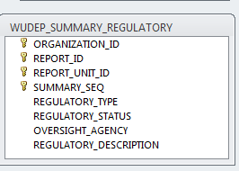
Other Items
Levi asked where the database fits into the plan to working with the pilot states. Dwane answered that the next step would be to take the example database, and create example XML data out of the data in the database. The plan for engaging the pilot states is to begin working with them once we have draft services, a working staging database, and a defined schema. The schedule calls for the pilots to begin later this year. Once the pilots begin, the states will have three options for engaging in the data exchange:
- State would build their own services that map to the standards and services defined by the WSWC
- The WSWC works with the state to deploy a Water One Flow/Python (WofPY) application in the state environment. This application would interact directly with the state database and generate the services in the standard Water Use Data Exchange Format.
- The WSWC works with the state to deploy a staging database from which the services would run. Under this scenario, the database discussed during this call would serve as the staging database.
The database discussed here will also serve as the internal WSWC database for Central Portal, and for other purposes within the WSWC.
Levi asked about who the universe of pilot states would be. Would they be limited to the states that are participating in the Workgroup calls?
Dwane answered that no, the pilot states wouldn’t be limited to the workgroup participants.
Levi asked what role Reclamation would play in this data exchange. He mentioned that Reclamation only has reservoir storage data that may be of value to the Water Use Data Exchange Schema, but the rest of their data wasn’t a good fit. Dwane answered by stating that the schema defined here was only part of the project. The WSWC is also interested in working with data providers to make observed data more available. Example data of this type within Reclamation included reservoir height data and stream gage data. Dwane mentioned that he and Sara had met with Reclamation in Denver (Mike Galbadon and his staff) in March of this year to discuss this project further. Dwane recommended that Levi talk to them to better understand what Reclamation’s plans are for these type of data. Dharhas also gave the example of how TX is currently ‘scraping’ the Reclamation web site to get reservoir and stream gage data for Elephant Butte Reservoir. He stated that this process would be so much easier if Recalmation were to share their data via a common set of services that adhered to a specific standard.
Levi asked about the coordination between the Water Use Data Exchange preject, and the interoperability work that US Army Corps of Engineers, USGS, and NOAA as part of the IWRSS/Federal Toolbox MOU. Dwane state that he was aware of this project, and was using his contacts in USGS to keep an eye on the project.
Dwane announced that he had two outreach opportunities coming up. The first is a presentation that Dwane will give to the Mountain West Water Institute. The other presentation is to EPA’s Exchange Network. He will provide an update on both of these presentations at the next call.
Call Schedules: Next call will be either June 4th, the week of June 11th, or the week of June 18th.

