WESTERN STATES WATER COUNCIL

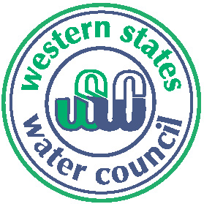 171st Council Meeting
Denver, Colorado
April 3-5, 2013

Sheraton Denver Downtown ADVANCE REGISTRATION FORM
1550 Court Place
Denver, Colorado 80202 Please return by March 15, 2013
1-303-626-2510

Wednesday, April 3 ► Field Trip

A field trip has been arranged for Council members and their guests. Please meet in the hotel lobby at 11:30 am for departure. The bus will depart from the hotel at 11:45 am.

We’ll first travel to Chatfield Reservoir. Thereafter, we’ll head to Strontia Springs Reservoir, part of Denver Water's system, where we’ll hear about Denver operations, and about fire damage from the 2002 fires, and the mitigation work ongoing upstream. We’ll then travel to REI to hear a brief explanation of the water rights associated with whitewater parks. The last stop is a visit to the Molson Coors Brewing Company in downtown Denver, for a brief talk about their water rights and water systems, as well as beer tasting. The bus will return to the hotel by 5:30 pm.

It is recommended that participants wear comfortable walking shoes, bring a hat, lightweight jacket, sunglasses, sunscreen, and an umbrella (in case of rain or as a sunshade provider).

A box lunch is included with the field trip, sponsored by the CO Water Conservation Board. Cost: $ 25.00 per person

Number attending Field Trip (at $25 each) # Amount Enclosed $ _________

Name(s)

___________________________________________________________________________________________________

Title

Company or Agency

Address

City/State/Zip

Telephone Email __________________________________________________

Payment Options: Check, credit card (VISA/MasterCard), purchase order, or ACH electronic transfer. Please notify us if your agency pays via electronic transfer. Our ACH routing number is 124002971 and our Federal Tax ID is 93-0551574.

Name on Card Credit Card # ________________________________________

Expiration Date Security Code________________________________________

Email to: credding@wswc.utah.gov OR Fax to: (801) 685-2559 OR
Mail to: Western States Water Council, 5296 Commerce Drive, Suite 202, Murray, UT 84107-5340

